NAME: Siva Dakshitha K REG.NO:192425395
EXPERIMENT-30
DESCRIPTION NUMERICAL PREDICTION ANALYSIS USING LINEAR REGRESSION THROUGH WEKA
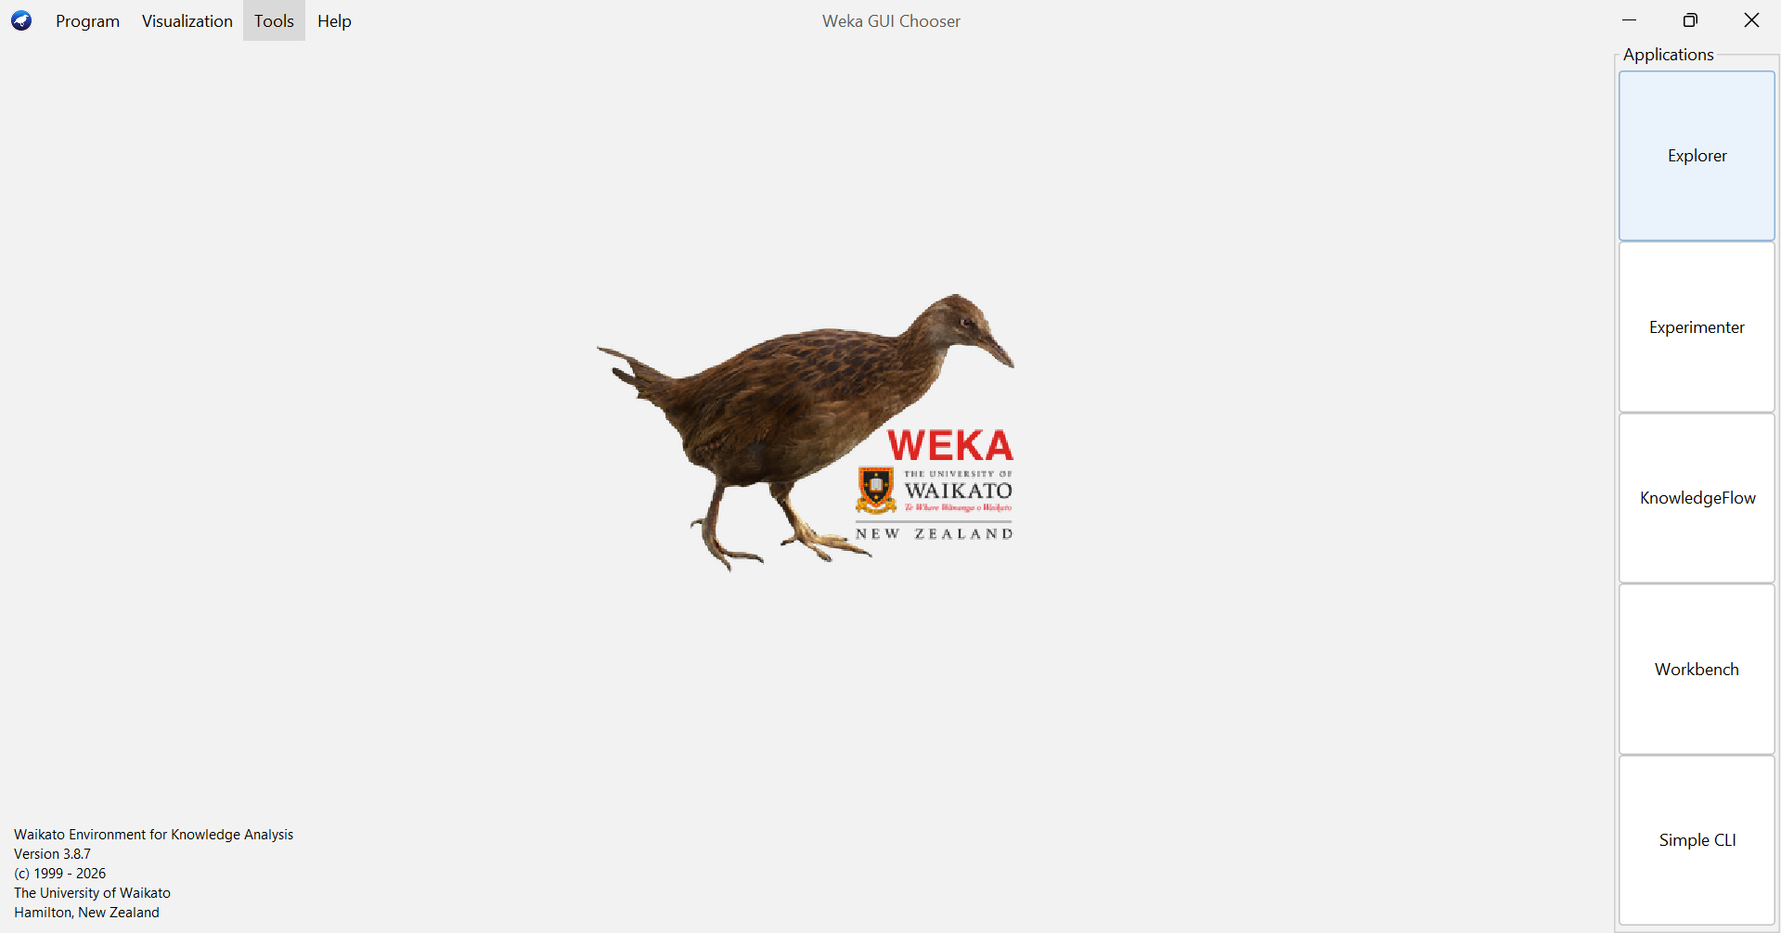
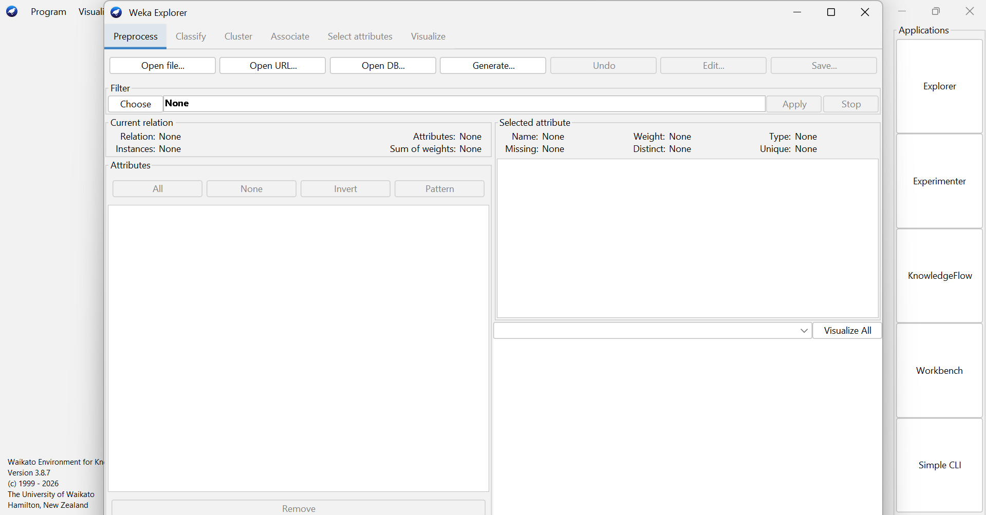
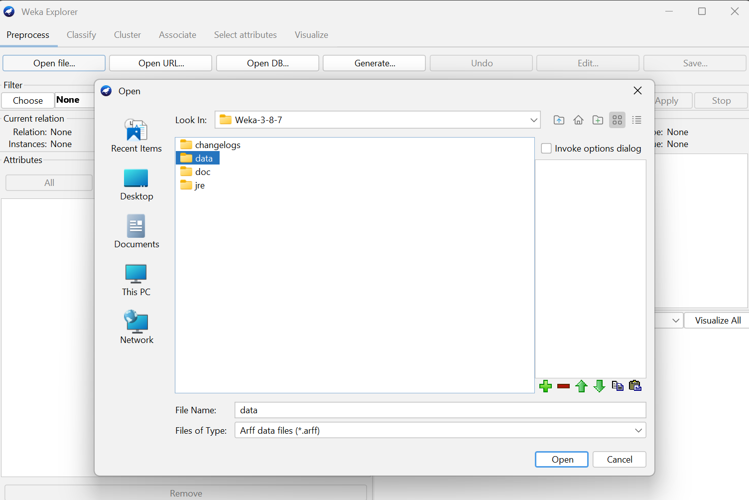

❖ When cross validation folds = 05 :

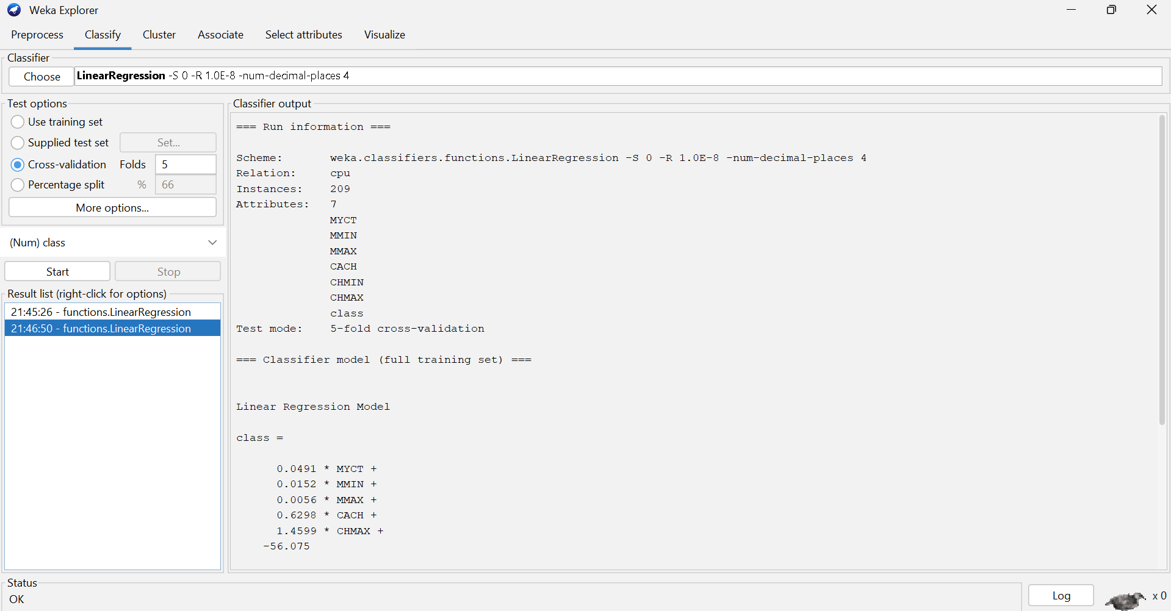
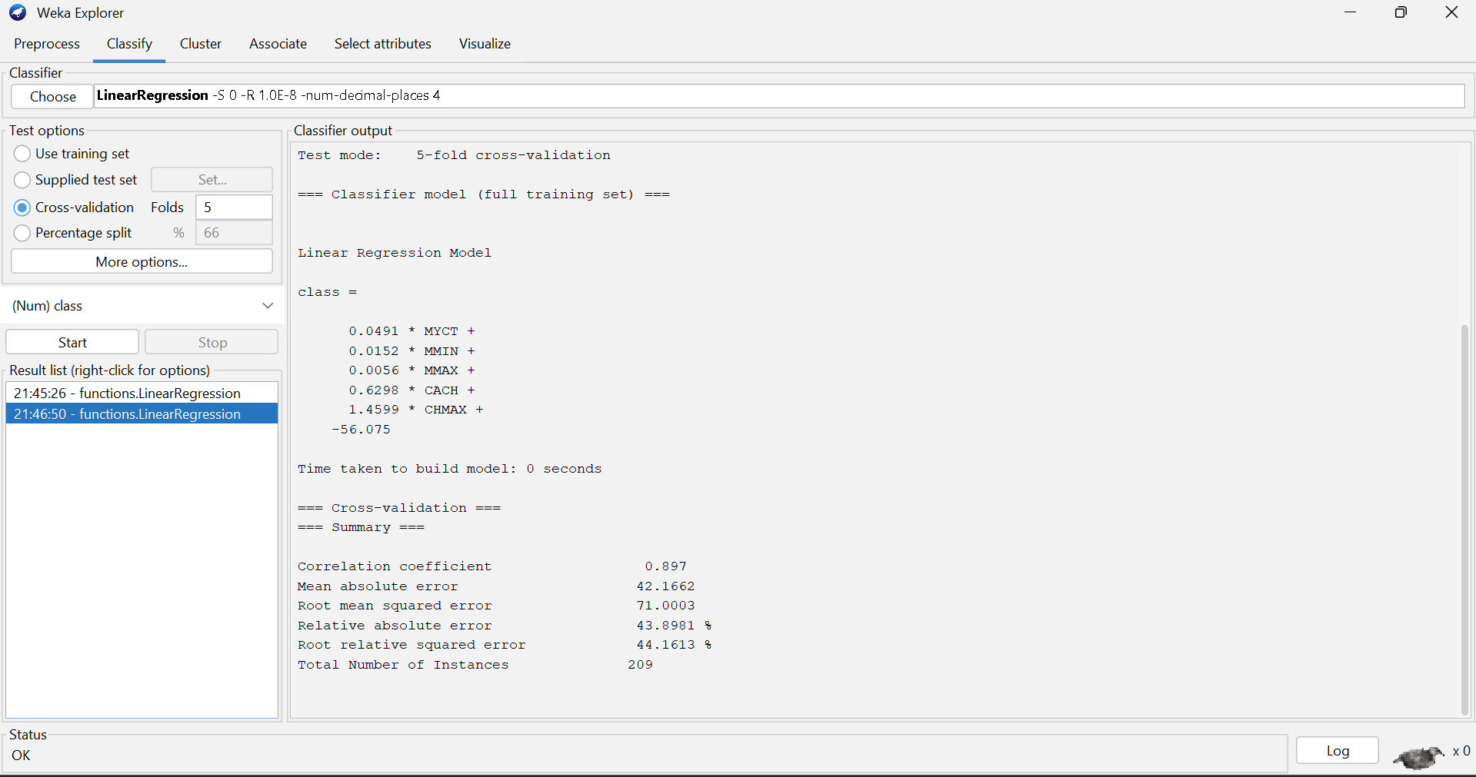
❖ When cross validation folds = 10 :
